https://www.kaggle.com/datasets/anshtanwar/pets-facial-expression-dataset/data

This document is a continuation of the previous documentations on Artificial Neural Network (ANN) Basics and Convolutional Neural Network (CNN) Basics.

In this document we explore different Nets developed by different authors where their architectures were shown to have improvement to the CNN models.

Developed CNN Nets
Remember that CNN comprises layers, and each layer is simply added on top of each other. What if I told you that the layers can be arranged as anything you want it to be.

Understand that each model can also be considered a layer, as all of them has the same input output and hidden layer interaction to each other. You can therefore stack one layer on top of another, one model on top of another layer, and one model on top of another model, creating a brand new model with different (architecture), etc. As previously mentioned, there are no rules to how you define your Neural network model, as long as it behaves in a way that improves the accuracy of the end product (refer to the types of CNN tasks to determine whatever your end product is)

In document 2 regarding CNN Basics, the CNN model we did was considered a Sequential model, where the layers are linearly passing their inputs and outputs to the next layers.
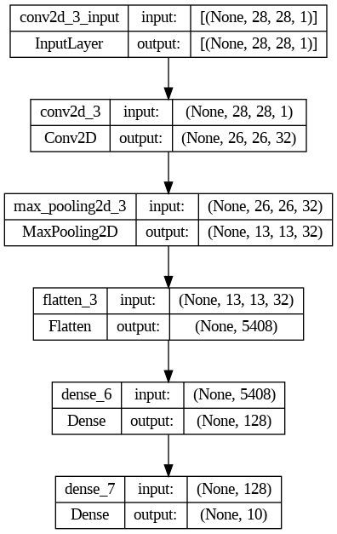
Figure 0.1. Model of CNN trained on MNIST data from Document 2
As shown in Figure 0.1. the layers have a visible sequence to the processes, hence the name.
Sequential model refers to the type of neural network architecture where the layers are stacked sequentially one after another.

Non-Sequential models will not be thoroughly discussed in this chapter as our topic is to discuss existing developed CNN nets instead.

In Neural Network, Net means architecture (“Neural Network”). A ResNet describes the name of a CNN architecture. In this chapter, we discuss some of the most widely known CNN nets that have caused breakthroughs, or are champions in hackathon competitions, leading to a breakthrough.

This chapter uses reference, https://machinelearningmastery.com/object-recognition-with-deep-learning/

1. Region-Based Convolutional Neural Network(R-CNN)

